What Is A Suburb

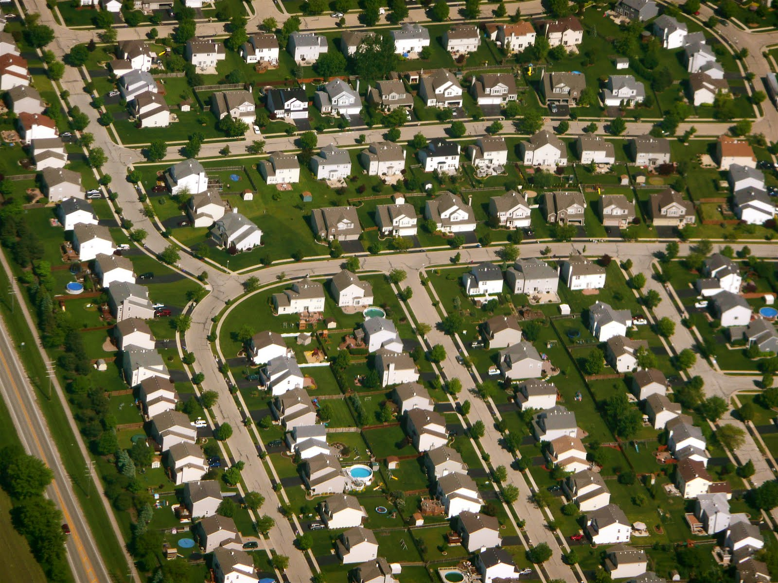
It is a residential area or a mixed-use area, either existing as part of a city or urban area or as a separate residential community within commuting distance of a city
Some suburbs have a degree of administrative autonomy, and most have lower population densities than inner city neighborhoods. Suburbs first emerged on a large scale in the 19th and 20th centuries as a result of improved rail and road transport, which led to an increase in commuting.^{[1]} Suburbs tend to proliferate around cities that have an abundance of adjacent flat land.^{[2]}
As people gain wealth around the world, they all usually tend to do the same thing: spread out. A common dream shared among people of all cultures is to have a piece of land to call their own. The suburbs are the place that many urban dwellers turn to because it offers the space needed to satisfy these dreams.

Suburbs are the communities surrounding cities that are usually made up of single-family homes, but are increasingly including multifamily homes and places like malls and office buildings. Emerging in the 1850s as a result of a fast rising urban population and improving transportation technology, suburbs have remained a popular alternative to the city even today. As of 2000, about half of the population of the United States lived in suburbs.
Suburbs are generally spread out over greater distances than other types of living environments. For instance, people may live in the suburb in order to avoid the density and untidiness of the city. Since people have to get around these vast stretches of land, automobiles are common sights in suburbs. Transportation (including, to a limited extent, trains and buses) plays an important role in the life of a suburban resident who generally commutes to work.
People also like to decide for themselves how to live and what rules to live by. Suburbs offer them this independence. Local governance is common here in the form of community councils, forums, and elected officials. A good example of this is a Home Owners Association, a group common to many suburban neighborhoods that determines specific rules for the type, appearance, and size of homes in a community.
People living in the same suburb usually share similar backgrounds with regard to race, socioeconomic status, and age. Often, the houses that make up the area are similar in appearance, size, and blueprint, a layout design referred to as tract housing, or cookie-cutter housing.

